Uniform Circular Motion

PHYS 211L – H02

Tuesday 10:05am – 12:05pm

Abstract

In this lab, we investigated uniform circular motion, paying close attention to the relationship between force and acceleration. Using this relationship, we determined the mass of an object experiencing uniform circular motion. For example, we found that the mass of a bob traveling in a circle of radius 0.14 meters is (0.394 ± 0.875) kg, while the actual measured mass of the bob was 0.35 kg. Within uncertainties, our calculated mass of the bob agreed with our measured mass for only two of our four trials. We suck.

Introduction

Procedure

In this lab, we used the following materials: the circular motion apparatus, a set of weights and weight holders, a stopwatch, a meter stick, and a laboratory balance.

First,

Results/Analysis/Physics

All Raw and Calculated Data

|  |  |  |  |  |  |  |  |  |  |
| --- | --- | --- | --- | --- | --- | --- | --- | --- | --- |
| Radius when rotating (m) | Uncertainty in radius (m) | Time for 15 rotations (s) | Period of the bob (rev/s) | Mass needed to position the bob at radius (kg) | Uncertainty in the mass required to position the bob (kg) | Force exerted on the bob by the suspended mass (N) | Frequency of Rotation (m/s/s) | Calculated mass of the bob (kg) | Percent uncertainty in the mass of the bob |
| 0.18 | 0.36 | 9.34 | 1.606 | 0.7 | 0.20 | 6.867 | 4.425 | 1.552 | .800 |
| 0.22 | 0.44 | 7.32 | 2.049 | 1.30 | 0.40 | 12.75 | 4.239 | 2.314 | .808 |
| 0.14 | 0.28 | 13.52 | 1.109 | 0.20 | 0.10 | 1.962 | 4.984 | 0.394 | .875 |
| 0.16 | 0.32 | 11.8 | 1.271 | 0.35 | 0.15 | 3.434 | 4.970 | 0.691 | .850 |

Free Body Diagram of the Bob While it’s Undergoing Uniform Circular Motion

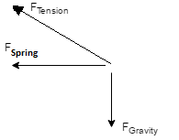

Free Body Diagram of the Bob While it’s not in Motion and the Weight Hanger is Attached

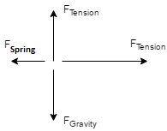

Terrible fucking graph

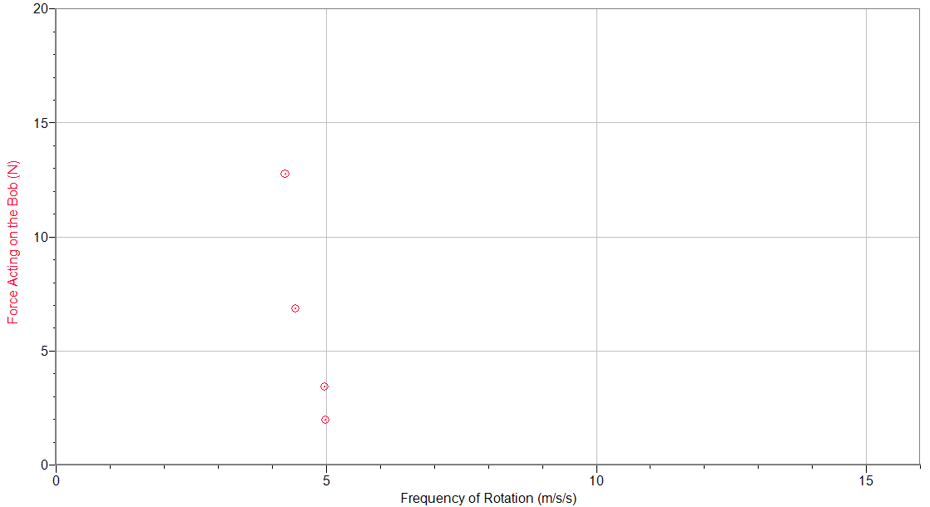

Conclusion

Lab Questions and Calculations

1. Uniform circular motion is the motion of an object in a circle at a constant speed. Our actual procedure did not follow this definition due to air resistance.

4. The force acting on the bob divided by the frequency of rotation gives the theoretical mass of the bob. In terms of the graph, the slope of the line is the theoretical mass of the bob.

5. Calculating the mass using each individual point results in two theoretical masses that do agree with our measured mass within uncertainties and two that do not. Using the graph, we get a value that does not agree with our measurement within uncertainty.

6. The bob is accelerating towards the vertical shaft that it is attached to, which is how the bob’s path of motion is a circle.